**REPETITIVE STRUCTURES**

**ASSIGNMENT # 2**



**Spring 2019**

**CSE102 Computer Programming**

Submitted by: **SHAH RAZA**

Registration No. : **18PWCSE1658**

Class Section: **B**

“On my honor, as student of University of Engineering and Technology, I have neither given nor received unauthorized assistance on this academic work.”

Student Signature: ______________

Submitted to:

**Engr. Madiha Sher**

March 18, 2019

Department of Computer Systems Engineering

University of Engineering and Technology, Peshawar

1. Calculate the sum of odd natural numbers 1+3+5+7+……………. .+n using while loop. Take n as input from user.

**Code:**

#include <iostream>

using namespace std;

int main()

{

//Variable declaration

int num,sum=0,i=1;

cout << "Enter an odd integer: ";//Display message

cin>>num;

//Logic for finding sum of odd integers

while(i<=num)

{

sum=sum+i;

i=i+2;

}

//Display message

cout <<"The sum of odd natural numbers up to "<<num<<" is: "<<sum;

return 0;

}

### **Output (Compilation, Debugging & Testing):**

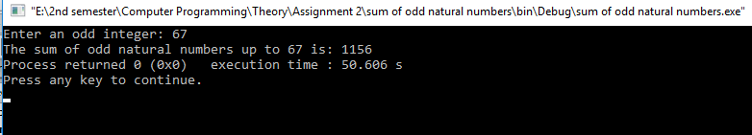

1. Write a program to find sum as Y of the following series excluding multiples of 3 in the series:

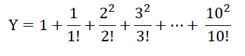

**Code:**

#include <iostream>

using namespace std;

int main()

{

float Y=1; //Variable declaration

for(int i=1;i<=10;i++)//Loop

{

if(i%2==1)

{

float Factorial=1;

//factorial

for(int f=1;f<=i;f++)

{

Factorial= Factorial*f;

}

//Square

float sq=i*i;

Y=Y+(sq/Factorial);

}

}

cout<<"The answer is: "<<Y;

return 0;

}

### **Output (Compilation, Debugging & Testing):**

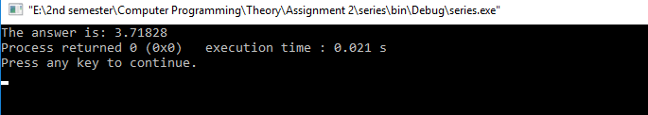

1. Write a program to produce the output as shown below using spaces and tabs:

x | y | expressions | results

6 | 3 | x=y+3 | x=6

6 | 3 | x=y-2 | x=1

6 | 3 | x=y*5 | x=15

6 | 3 | x=x/y | x=2

6 | 3 | x=x%y | x=0

**Code:**

#include <iostream>

using namespace std;

int main()

{

cout<<"\n\n";

cout << "\tx\t|\ty\t|\texpressions \t|\tresults " << endl;

cout << "\t6\t|\t3\t|\tx=y+3 \t|\tx=6 " << endl;

cout << "\t6\t|\t3\t|\tx=y-2 \t|\tx=1 " << endl;

cout << "\t6\t|\t3\t|\tx=y*5 \t|\tx=15" << endl;

cout << "\t6\t|\t3\t|\tx=x/y \t|\tx=2" << endl;

cout << "\t6\t|\t3\t|\tx=x%y \t|\tx=0" << endl;

return 0;

}

### **Output (Compilation, Debugging & Testing):**

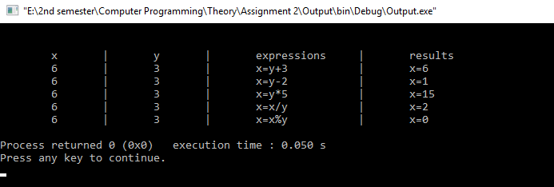

1. Given x=3.0, y=12.5, z= 523.3, A=300.0, B=1200.5, C=5300.3, Write a program to display the following using spaces and tabs in cout statement:

x y z= 3.0 | 12.5 | 523.3 |

A B C= 300.0| 1200.5| 5300.3|

-----------------------------------------------------------------------------------------

X y z= |3.00 |12.50 |523.30

A B C= |300.00 |1200.50 |52300.30

**Code:**

#include <iostream>

using namespace std;

int main()

{

cout<<"x\ty\tz=\t3.0|\t\t12.5|\t\t523.3|"<<endl;

cout<<"A\tB\tC=\t300.0|\t\t1200.5|\t\t5300.3|\n"<<endl;

cout<<"--------------------------------------------------------------------\n";

cout<<"x\ty\tz=\t|3.00\t\t|12.50\t\t|523.30"<<endl;

cout<<"A\tB\tC=\t|300.00\t\t|1200.50\t|52300.30\n"<<endl;

return 0;

}

### **Output (Compilation, Debugging & Testing):**

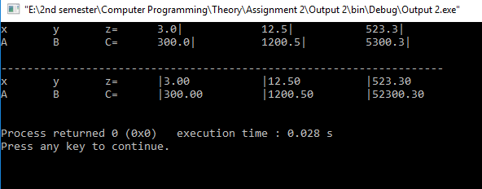

1. Write a program that reads n integers as input from user and display the maximum value that the user entered (using do while loop).

**Code:**

#include <iostream>

using namespace std;

int main()

{

//Variable declaration

int num,greatest_number=0;

do //Loop

{

cout<<"Enter a number: "; //Display message

cin>>num;//Input num

if(num>greatest_number)

{

greatest_number=num;

}

}while(num!=-1);

cout<<"The greatest number you entered is: "<<greatest_number;

return 0;

}

### **Output (Compilation, Debugging & Testing):**

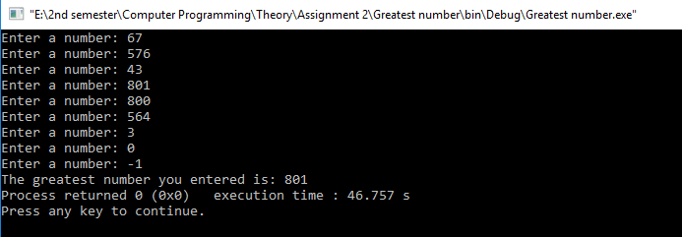

1. Write a program to calculate GPA for multiple of students. Your program shall ask each student to enter the number of subjects, credit hours of each subject and grade of each subject. Display the GPA obtained by the student. Your program shall ask the user if there are other students who want to calculate their GPA. Calculate again if the user enters y/Y (using do while loop).

**Code:**

#include <iostream>

using namespace std;

int main()

{

//Variable declaration

int num,credit_hour;

char ch,grade,a;

float gpa,nominator=0,denominator=0,cgpa;

do //Loop

{

//Display message

cout << "Enter number of subjects: ";

cin>>num; //Input num

int subject_number=0;

for(int i=1;i<=num;num--)

{

subject_number++;

cout<<"Enter your Grade in subject #"<<subject_number<<": "; //Display message

cin>>grade>>a;//Input grade and a(+,-,0)

switch(grade)

{

case 'A':

if(a=='0')

gpa=4.00;

else if(a=='-')

gpa=3.67;

else

cout<<"Invalid Grade";

break;

case 'B':

if(a=='+')

gpa=3.33;

else if (a=='0')

gpa=3.00;

else if(a=='-')

gpa=2.67;

else

cout<<"Invalid Grade";

break;

case 'C':

if(a=='+')

gpa=2.33;

else if (a=='0')

gpa=2.00;

else if(a=='-')

gpa=1.67;

else

cout<<"Invalid Grade";

break;

case 'D':

if(a=='+')

gpa=1.33;

else if (a=='0')

gpa=1.00;

else

cout<<"Invalid Grade";

break;

case 'F':

gpa=0.00;

break;

default:

cout<<"Invalid Grade";

}

cout<<"Credit hour(s) of subject #"<<subject_number<<" :"; //Display message

cin>>credit_hour; //Input credit_hour

//calculations

nominator=nominator+(gpa*credit_hour);

denominator=denominator+credit_hour;

cgpa=nominator/denominator;

}

//Display message

cout<<"Your GPA is: "<<cgpa<<"\n";

cout<<"Is there another student who want to calculate their GPA? (Y/N) "; //Display message

cin>>ch; //Input ch(Y/N)

}while(ch!='n'&& ch!='N');

return 0;

}

### **Output (Compilation, Debugging & Testing):**

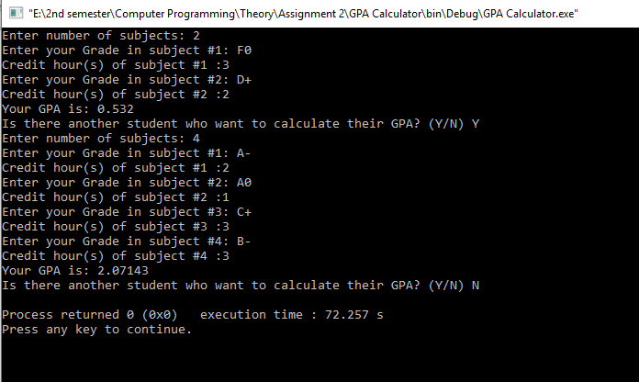

1. Use nested for loops (Loops inside Loops) to construct programs that display the following patterns.

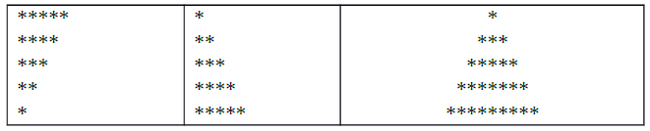

**Code:**

#include <iostream>

using namespace std;

int main()

{

//PART A

int a=6;

for(int i=5;i>=1;i--)

{

a--;

for(;1<=i;i--)

cout<<"*";

cout<<endl;

i=a;

}

cout<<"\n";

//PART B

a=0;

for(int i=1;i<=5;i++)

{

a++;

for(;i>=1;i--)

cout<<"*";

cout<<endl;

i=a;

}

//PART C

int asterisks=1,spaces;

for(int i=5;i>=1;i--)

{

a=asterisks+2;

spaces=i-1;

for(;spaces>=1;spaces--)

cout<<" ";

for(;asterisks>=1;asterisks--)

cout<<"*";

cout<<endl;

asterisks=a;

}

return 0;

}

### **Output (Compilation, Debugging & Testing):**

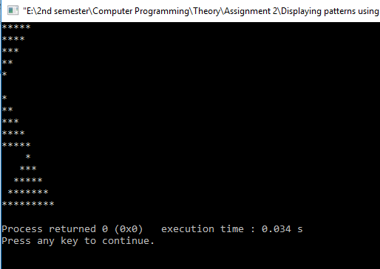

1. Write a program to display the following (using while loop):
2. 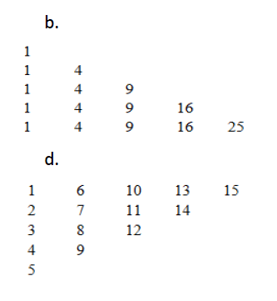
3. 

**Code:**

#include <iostream>

using namespace std;

int main()

{

//PART A

int i=1,b=1;

while(i<=5)

{

b++;

int a=1;

while(i>=1)

{

cout<<a*a<<" ";

a++;

i--;

}

cout<<endl;

i=b;

}

cout<<"\n\n";

//PART B

i=5,b=5;

int c=0;

while(i>=1)

{

b--;

c++;

int a=c,d=5;

while(i>=1)

{

cout<<a<<" ";

a=a+d;

d--;

i--;

}

cout<<endl;

i=b;

}

return 0;

}

### **Output (Compilation, Debugging & Testing):**

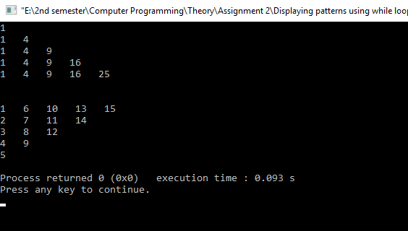

1. Write a program to find the sum & reverse of digits and check if it is Palindrome or not. Your program shall output the reverse of the same with suitable messages.

Ex: Num: 2014, Reverse: 4102, Not a Palindrome

Ex: Num: 12521, Reverse: 12521, Palindrome

**Code:**

#include <iostream>

using namespace std;

int main()

{

//Variable declaration

int num,rev=0,sum=0;

cout << "Enter a Number: "; //Display message

cin>>num; //Input num

int a=num;

while(num!=0) //Loop

{

int remainder=num%10;

rev=(rev*10)+remainder;

sum=sum+remainder;

num=num/10;

}

switch(a==rev)

{

case 1:

cout<<"Num: "<<a<<", Reverse: "<<rev<<", Sum: "<<sum<<", Palindrome";

break;

case 0:

cout<<"Num: "<<a<<", Reverse: "<<rev<<", Sum: "<<sum<<", Not a Palindrome";

break;

}

return 0;

}

### **Output (Compilation, Debugging & Testing):**

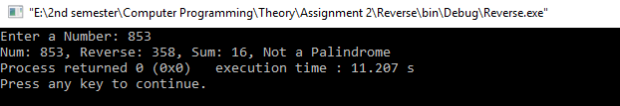

1. Write a program to check whether a given 3 digit number is Armstrong number or not.

An Armstrong number of three digits is an integer such that the sum of the cubes of its digits is equal to the number itself. For example, 371 is an Armstrong number since 33 + 73 + 13 = 371.

For Example: 1643 is an Armstrong number since 14 + 64 + 44 + 34 = 1643.

**Code:**

#include <iostream>

using namespace std;

int main()

{

int num,sum=0; //Variable declaration

cout << "Enter a number: "; //Display message

cin>>num; //Input num

int a=num;

while(num!=0)

{

int remainder=num%10;

sum=sum+(remainder*remainder*remainder);

num=num/10;

}

if(sum==a)

cout<<"This is an Armstrong number";

else

cout<<"This is not an Armstrong number";

return 0;

}

### **Output (Compilation, Debugging & Testing):**

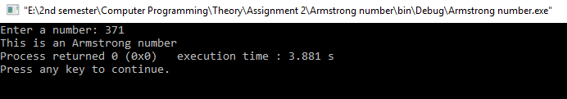

1. Write a program to count number of digits and bits in a number.

**Code:**

#include <iostream>

using namespace std;

int main()

{

//Variable declaration

int num,counter=0;

cout << "Enter a number: "; //Display message

cin>>num; //Input num

int a=num;

//Number of Digits

while(num!=0) //Loop

{

counter++;

num=num/10;

}

cout<<"This number has "<<counter<<" digits\n";

//Number of bits

counter=0;

while(a!=0) //Loop

{

counter++;

a=a>>1;

}

cout<<"This number has "<<counter<<" bits\n";

return 0;

}

### **Output (Compilation, Debugging & Testing):**

